BADGE REQUEST FORM – ACCESS TO UCSC SERVICES

Name Surname ___Camila Fernanda Utreras Cifuentes_________________________________

Date of birth ____23/08/1995___________ Place of birth _____Santiago, Chile _________________

University ______Universidad del Desarrollo, Chile ___________________________________

Permanent address_____Fray Angelico 66, depto 205, Las Condes, Chile________________________

Italian address ____Via Giuseppe Giacosa, 58, 20127, Milan, Lombardy, Italy 20127 Milan______

Telephone ______________________ Mobile __+56969165513__e-mail __cutrerasc@udd.cl_________

DECLARES

____that she carries out scientific research on experimental design and learning optimization related to retirement decision-making__________________________

within the Institute/Department: __Department of Economic Policy, Università Cattolica del Sacro Cuore ______

from __19/01/2026___________ through ___15/04/2026______________________________

REQUESTS

BADGE issue; the issued badge will be valid for the above indicated period and is to be returned at the end of permanence at Università Cattolica del Sacro Cuore.

DATE:__16/12/2025__________ SIGNATURE
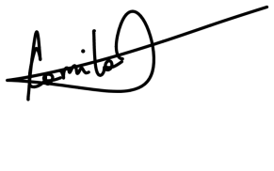

________________________________

SIGNATURE OF HOSTING INSTITUTE/DEPARTMENT CHAIR

_______________________________________

ENCLOSURE: 1 PASSPORT-SIZE PHOTOGRAPH

